Module 1 Foundation DBT
The milestones
4 Lessons

- LI Introduction to Dialectical Behaviour Therapy (DBT) & Radically Open Dialectical Behaviour Therapy (RO DBT) Skills
- L2 BioPsychSocial Approach to Understanding Problems
- L3 Neurosequential Model of Therapeutics (NMT)
- L4 Chain Analysis
- Homework

LI DBT & RO DBT Skills
Teaching skills are essential to DBT. This course teaches the skills utilized in Dialectical Behaviour Therapy but does not replace the individual therapy process. It is meant to companion your therapy to give you a new understanding and concrete processes for change. DBT skills are life skills. Many people have not had the opportunity to learn these skills or have models for a skillful approach to life. These skills are meant to be practiced daily and become a lifestyle or way of functioning instead of “toolbox” skills only meant to be taken out periodically.
Learning DBT skills is like learning a new language. Encourage yourself and practice as often as possible. The skills are interconnected and take time and experience to use effectively. When we learn new languages, words have limited meaning until they are put into sentences and then into conversations. Skills work the same way. Keep connecting skills until they form chains of new behaviours, creating a more satisfying life. We learn a language through speaking it, and we must practice new skills every day until it's fluent.
What is DBT?
Dialectical behaviour therapy (DBT) is an evidence-based psychotherapy that began with efforts to treat personality disorders and interpersonal conflicts. There is evidence that DBT can be useful in treating mood disorders, suicidal ideation, and changes in behavioural patterns such as self-harm and substance use. DBT evolved into a process in which the therapist and client work with acceptance and change-oriented strategies and ultimately balance and synthesize them in a manner comparable to the philosophical dialectical process of hypothesis and antithesis, followed by synthesis. DBT is considered part of the "third wave" of cognitive-behavioural therapy, and DBT adapts CBT to assist clients in dealing with stress.
This approach was developed by Marsha M. Linehan, a psychology researcher at the University of Washington, to help people increase their emotional and cognitive regulation by learning about the triggers that lead to reactive states and helping to assess which coping skills to apply in the sequence of events, thoughts, feelings, and behaviours to help avoid undesired reactions.
Linehan developed DBT as a modified form of cognitive behavioural therapy (CBT) in the late 1980s to treat people with borderline personality disorder (BPD) and chronically suicidal individuals. Research on its effectiveness in treating other conditions has been fruitful; DBT has been used by practitioners to treat people with depression, drug and alcohol problems, post-traumatic stress disorder (PTSD), traumatic brain injuries (TBI), binge-eating disorder, and mood disorders. Research indicates that DBT might help patients with symptoms and behaviours associated with the spectrum of mood disorders, including self-injury. Work also suggests its effectiveness with sexual abuse survivors and chemical dependency.

DBT combines standard cognitive-behavioural techniques for emotion regulation and reality-testing with concepts of distress tolerance, acceptance, and mindful awareness largely derived from contemplative, meditative practice. DBT is based upon the biosocial theory of mental illness and is the first therapy that has been experimentally demonstrated to be generally effective in treating BPD. The first randomized clinical trial of DBT showed reduced rates of suicidal gestures, psychiatric hospitalizations, and treatment drop-outs when compared to treatment as usual.

DBT strives to have the client view the therapist as an ally rather than an adversary in the treatment of psychological issues. Accordingly, the therapist aims to accept and validate the client's feelings at any given time while, nonetheless, informing the client that some feelings and behaviours are maladaptive and showing them better alternatives. DBT focuses on the client acquiring new skills and changing their behaviours, with the ultimate goal of achieving a "life worth living," as defined by the client.

What Is RO DBT?
Radically Open Dialectical Behaviour Therapy (RO DBT) is an evidence-based treatment targeting a spectrum of disorders characterized by excessive self-control, often referred to as overcontrol (OC). It is supported by 20 years of clinical experience and translational research that parallels established guidelines for treatment development (e.g., UK Medical Council, 2008; Rounsville & Carroll, 2001; 2006).
RO DBT is a type of cognitive-behavioural therapy developed by Dr. Thomas R. Lynch for disorders of overcontrolling. Excessive self-control or overcontrol is a type of personality or coping style that can lead to social isolation, poor interpersonal functioning, and severe and difficult-to-treat mental health problems. OC behaviours are often observed in Eating Disorders, Autism Spectrum Disorder, Chronic Depression, and Obsessive-Compulsive Personality Disorder (not OCD, but more related to perfectionism, orderliness, and control). Individuals characterized by overcontrolled coping tend to be serious about life, set high personal standards, work hard, behave appropriately, and frequently will sacrifice personal needs in order to achieve desired goals or help others; yet inwardly, they often feel “clueless” about how to join in with others or establish intimate bonds. Thus, overcontrol works well when it comes to sitting quietly in school or building a rocket; but it creates problems when it comes to social relationships.
Psychological health or well-being in RO DBT is hypothesized to involve three core transacting features:
1. Receptivity and Openness to new experiences and disconfirming feedback in order to learn.
2. Flexible control in order to adapt to changing environmental conditions.
3. Intimacy and social connectedness (with at least one other person) based on the premises that species survival requires capacities to form long-lasting bonds and work in groups
RO DBT holds that “facts” and “truth” can often be misleading because we “don’t know what we don’t know”, life is constantly in flux, and there is much that influences us that we aren’t aware of. Radical openness involves a willingness to doubt or question ourselves and our convictions without falling apart. It helps relationships because it models humility and willingness to learn from what the world offers. RO DBT differs from other treatments by focusing on helping with deficits in social signalling that reduce social connectedness. But what is a social signal? A social signal is any behaviour a person exhibits in the presence of another person, regardless of its intention (sometimes a yawn is just a yawn) or conscious awareness (for example, an involuntary sigh). We are constantly socially signalling when around others (for example, via body movements and voice tone), even when we deliberately try not to (silence can be just as powerful as nonstop talking).
The reason for this is that the negative results of overcontrol are usually related to social relationships. Overcontrolled individuals see new or unfamiliar (especially social) situations as dangerous rather than rewarding due to biological-temperamental differences and social/historical learning experiences. Their tendencies to hide expressions of emotion make it harder for others to know their true intentions, which is needed to form close social bonds. Consequently, RO DBT targets indirect, hidden, and constrained social signalling as the main source of emotional loneliness, isolation, and misery over problematic internal experiences (e.g., negative emotions, harsh self-judgment, distorted thinking) and treatment strategies are designed to enhance social connectedness; including new skills to activate areas of the brain associated with the social-safety system and signal cooperation by deliberately changing body postures and facial expressions (e.g. raising eyebrows when stressed), encourage genuine self-disclosure, and break down overlearned expressive inhibitory barriers (via skills designed to encourage playful behaviour and candid expression).
Thus, regarding long-term health, what a person feels or thinks inside is considered less important in RO DBT, whereas how a person communicates or socially signals their private experience to others and its impact on social connectedness is given priority. When you are lonely, it’s hard to feel happy, no matter how much you try to accept or change your circumstances, think more positively, keep busy, exercise, practice yoga, or distract yourself. Revealing intentions and emotions to other members of our species was essential to creating the types of strong social bonds that are the cornerstone of human tribes. In the long run, we are tribal beings, and we want to share our lives with other members of our species. Essentially, when we feel part of a tribe, we naturally feel safe and worry less. RO DBT is designed to help emotionally lonely, overcontrolled clients learn how to make this a reality.

L2 BioPsychoSocial Approach
The Biopsychosocial model was first conceptualized by George Engel in 1977, suggesting that to understand a person's medical condition, it is not simply the biological factors to consider but also the psychological and social factors.
· Bio (physiological pathology)
· Psycho (thoughts, emotions, and behaviours such as psychological distress, fear/avoidance beliefs, current coping methods and attribution)
· Social (socio-economical, socio-environmental, and cultural factors such as work issues, family circumstances and benefits/economics)
It’s the transactions that count between the person and the social environment. Biology, Personality, and the Social Context influence the person; the person reciprocates and influences the social environment, and the social environment reciprocates and influences the person. And so on and so on.
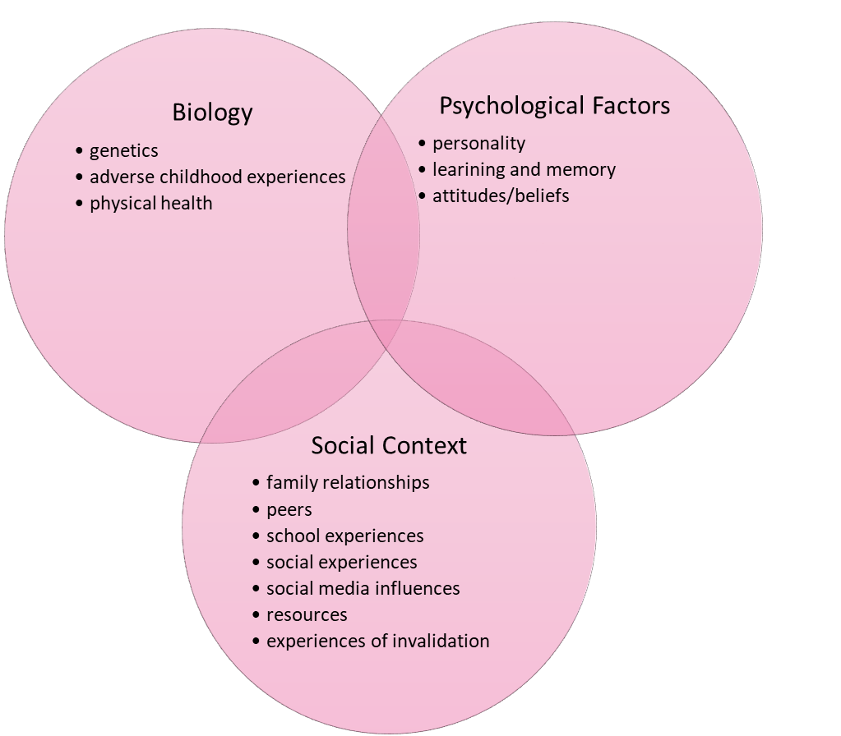
Why do I have so much trouble controlling my emotions and my actions?
Emotional vulnerability is biological: It’s simply how some people are born.
- They are more sensitive to emotional stimuli; they can detect subtle emotional information in the environment that others don’t even notice.
- They experience emotions much more often than others.
- Their emotions seem to hit for no reason, from out of the blue.
- They have more intense emotions.
- Their emotions hit like a ton of bricks.
- And their emotions are long-lasting.

Impulsivity also has a biological basis: Regulating action is harder for some than for others.
- They find it very hard to restrain impulsive behaviours.
- Often, without thinking, they do things that get them in trouble.
- Sometimes, their behaviour seems to come out of nowhere.
- They find it very hard to be effective.
- Their moods get in the way of organizing to achieve their goals.
- They cannot control behaviours linked to their moods.
An invalidating social environment can make it very hard to regulate emotions.
- An invalidating environment doesn’t seem to understand your emotions.
- It tells you your emotions are invalid, weird, wrong, or bad.
- It often ignores your emotional reactions and does nothing to help you.
- It may say things like, “Don’t be such a baby!” “Quit your blubbering.” “Quit being such a chicken and just solve the problem.” or “Normal people don’t get this frustrated.”
- People who invalidate are often doing the best they can.
- They may not know how to validate or how important it is to validate, or they may be afraid that if they validate your emotions, you will get more emotional, not less.
- They may be under high stress or time pressure, or they may have too few resources themselves.
- There may be just a poor fit between you and your social environment: You may be a tulip in a rose garden.
- They find it very hard to be effective.
- Their moods get in the way of organizing to achieve their goals.
- They cannot control behaviours linked to their moods.

An ineffective social environment is a big problem when you want to learn to regulate emotions and actions.
- Your environment may reinforce out-of-control emotions and actions.
- If people give in when you get out of control, it will be hard for you to get in control.
- If others command you to change but don’t coach you on how to do this, it will be hard to keep on trying to change.

L3 Neurosequential Model of Therapeutics (NMT)
The Neurosequential Model of Therapeutics (NMT) is a developmentally sensitive, neurobiology-informed approach to clinical problem-solving. NMT is not a specific therapeutic technique or intervention. It is an approach that integrates core principles of neurodevelopment and traumatology to inform the sequencing of therapeutic, educational and enrichment activities that match the needs and strengths of the individual.
​As described by Brandt and colleagues (2012) – “The Neurosequential Model of Therapeutics (NMT) (Perry, 2006) provides an integrated understanding of the sequencing of neurodevelopment embedded in the experiences of a person and supports biologically informed practices, programs, and policies.
In this course, we’ve informed the sequencing of skills used to correspond with the state of arousal/activation to increase the effectiveness of behavioural change.

NMT
Cortex
Limbic
Diencephalon
Brainstem
Guilt Shame
Alcohol - Substance Abuse
Relational Difficulties
Depressive & Effects Symptoms
Relational Difficulties
Calm
Thinking
Meaning
Alert
Attachment
Emotion
Alarm
Appetite
Sleep
Somatosensory Input
Fear
HR
Breathing
Temperature
Terror

L4 Chain Analysis

Vulnerability
Prompting Event
Links
Consequences

Vulnerability
Prompting Event
Links
Consequences
1. Describe the problem behaviour.
2. Describe the prompting event that started the chain of events leading to the problem behaviour.
3. Describe the factors happening before the event that made you vulnerable to starting down the chain of events toward the problem behaviour.
4. Describe in excruciating detail the chain of events that led to the problem behaviour.
5. Describe the consequences of the problem behaviour.
6. Describe skillful behaviours to replace problem links in the chain of events.
7. Develop prevention plans to reduce vulnerability to a stressful event.
8. Repair important or significant consequences of the problem behaviour.
- Describe the specific problem behaviour
Possible examples: overeating or overdrinking, lying, Rigidly holding an expectation, yelling at your kids, throwing a chair, having an overwhelming emotional outburst, holding back expression of needs, dissociating, putting off or refusing to do skills practice, etc.
A. Be very specific and detailed. No vague terms.
B. Identify exactly what you did, said, thought, or felt (if feelings are the targeted problem behaviour). Identify what you did not do.
C. Describe the intensity of the behaviour and other characteristics of the behaviour that are important.
D. Describe the problem behaviour in enough detail that an actor in a play or movie could recreate the behaviour exactly.
E. If the behaviour is something you did not do, ask yourself whether (a) you did not know you needed to do it (it did not get into short-term memory); (b) you forgot it and later it never came into your mind to do it (it did not get into long-term memory); (c) you put it off when you did think of it; (d) you refused to do it when you thought of it; or (e) you were willful and rejected doing it, or some other behaviour, thoughts, or emotions interfered with doing it. If (a) or (b) is the case, skip from here to Step 6 below (working on solutions). Otherwise, keep going from here.

2. Describe the specific prompting event that started the whole chain of behaviour.
Begin with the environmental event that started the chain. Always begin with some event in your environment, even if it doesn’t seem to you that the environmental event “caused” the problem behaviour. Otherwise, we could ask about any behaviour, thought, feeling, or experience, “What prompted that?” Possible questions to help you get at this are:
- What exact event precipitated the start of the chain reaction?
- When did the sequence of events that led to the problem behaviour begin? When did the problem start?
- What was going on right before the thought of or impulsed for the problem behaviour occurred?
- What were you doing/thinking/feeling/imagining at that time?
- Why did the problem behaviour happen on that day instead of the day before?
- Describe specific vulnerability factors happening before the prompting event. What factors or events made you more vulnerable to reacting to the prompting event with a problematic chain? Areas to examine are:
A. Physical illness; unbalanced eating or sleeping; injury.
B. Use of drugs or alcohol; misuse of prescription drugs.
C. Stressful events in the environment (either positive or negative).
D. Intense emotions, such as sadness, anger, fear, and loneliness.
E. Previous behaviours of your own that you found stressful coming into your mind.

3. Describe the factors that made you vulnerable to the prompting event.
There are times that the prompting event might not lead to the problem behaviour. The likely difference is the vulnerability factors that are at play during the chain of events. Spend some time thinking about what is different. Are you tired, hungry, thirsty, or feeling under the weather? Was there a difficult previous interaction? Were you surprised or disappointed by a sequence of events?

4. Describe in excruciating detail the chain of events that led to the problem behaviour.
Imagine that your problem behaviour is chained to the precipitating event in the environment. How long is the chain? Where does it go? What are the links? Write out all links in the chain of events, no matter how small. Be very specific, as if you are writing a script for a play. Links in the chain can be
A. Actions or things you do.
B. Body sensations or feelings.
C. Cognitions (i.e., beliefs, expectations, or thoughts).
D. Events in the environment or things others do.
E. Feelings and emotions that you experience.
What exact thought (or belief), feeling, or action followed the prompting event? What thought, feeling, or action followed that? What next? What next? And so forth.
Look at each link in the chain after you write it. Was there another thought, feeling, or action that could have occurred? Could someone else have thought, felt, or acted differently at that point? If so, explain how that specific thought, feeling, or action came to be. •• For each link in the chain, ask whether there is a smaller link you could describe.

5. Describe the outcomes and consequences of this behaviour. Be specific. (How did other people react immediately and later?)
How did you feel immediately following the behaviour? Later? What effect did the behaviour have on you and your environment?
6. Solution Analysis: Describe in detail at each point where you could have used skillful behaviour to head off the problem behaviour. What key links were most important in leading to the problem behaviour? (In other words, if you had eliminated these behaviours, the problem behaviour probably would not have happened.)
- Go back to the chain of behaviours following the prompting event. Circle each link where, if you had done something different, you would have avoided the problem behaviour.
- What could you have done differently at each link in the chain of events to avoid the problem behaviour? What coping behaviours or skillful behaviours could you have used?
- Describe in detail a prevention strategy for how you could have kept the chain from starting by reducing your vulnerability to the chain.
- Describe what you will do to repair important or significant consequences of the problem behaviour. Analyze: What did you really harm? What was the negative consequence you can repair? Look at the harm or distress you actually caused others and the harm or distress you caused yourself. Repair what you damaged. (Don’t bring flowers to repair a window you broke: fix the window! Repair a betrayal of trust by being very trustworthy long enough to fix the betrayal, rather than trying to fix it with love letters and constant apologies. Repair failure by succeeding, not by berating yourself.)

Homework: What behaviour do you want to work on

Vulnerability
Prompting Event
Links
Consequences
- What exactly is the major problem behavior that I am analyzing?
_______________________________________________________________________________________________________________________________________________________________________________________________________________
- What prompting event in the environment started me on the chain to my problem behavior? Include what happened right before the urge or thought came into my mind. Day prompting event occurred__________________________________________________________________________________________________________________________________________________________________________________________________________________________________________________________________________________________________________________________________________________
- Describe what things in myself and in my environment made me vulnerable. Day the events making me vulnerable started:
___________________________________________________________________________________________________________________________________________________________________________________________________________________________________________________________________________________________________________________________________________________________________________________________________________________________________________________________________________________________________
- List the links in the chain of events: Actions, Body sensations, Cognitions/Thoughts, Feelings and Events (in the environment). Be specific and use as much detail as possible. Remember, this is a process to look back and understand the problem to be able to create new solutions.
Chain of Problem Analysis | Chain of Solution Analysis

- Now, go back and list more skillful behaviors to replace ineffective behaviors in your chain; a solution analysis.
______________________________________________________________________________________________________________________________________________________________________________________________________________________________________________________________________________________________________________________________________________________________________________________________________________________________
- What exactly were the outcomes/consequences in the environment? And in myself? What harm did my problem behavior cause?
______________________________________________________________________________________________________________________________________________________________________________________________________________________________________________________________________________________________________________________________________________________________________________________________________________________________
- Prevention plans: Ways to reduce my vulnerability in the future: Ways to prevent precipitating event from happening again:
_________________________________________________________________________________________________________________________________________________________________________________________________________________________________________________________________________________________________________________________________________________________
- Plans to repair, correct, and overcorrect the harm:
____________________________________________________________________________________________________________________________________________________________________________________________________________________________________________________________________________________

